2023

Sadiq Tijjani Umar

University Of Bath

Word Count: 2592

ME 50367: Water Wells In Ghana

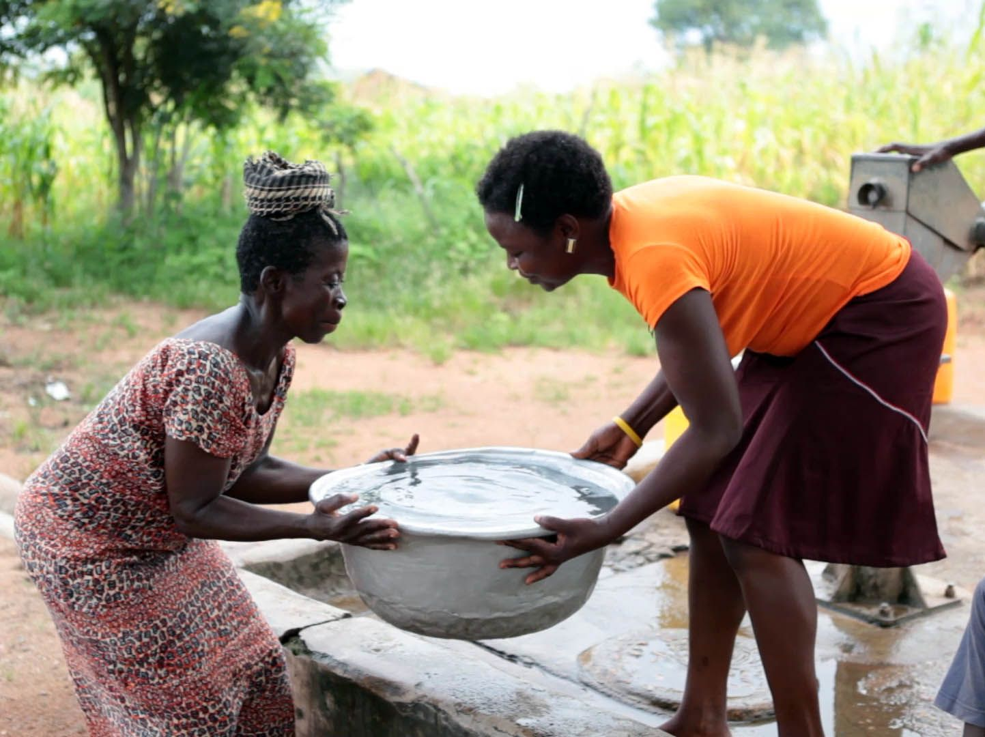

Table of Contents

*Introduction* 2

*Section One: The Risk Register* 2

*Section Two: Stakeholder Management* 5

References 6

## Introduction

The word project is coined from the Latin *projectare* which means “to thrust forward” or “to cast forward in the mind” (Etymoline,2020) implying some notion of being able to fix an ever evolving object or process into the gaze of the mind’s eye. The very etymology of the word project implies some sort of process management, a project is any structured endeavor or procedure undertaken to arrive at a unique result, a result which can be defined in terms of outcomes, outputs or benefits, to be able to deliver on these outcomes a project usually requires an evolution mitigation strategy as it were, something(s) that acts as a medium through which specific technical skills can be applied to meet the project requirements while also providing a framework for moving labor networks from a current state to a desired future state, this something is usually delineated into two composites, project management having to do with the former and change management having to do with the latter.

The water wells in Ghana project aims to build confined water wells across a region of Ghana known as Tamale, to be able to do this water wells which extract groundwater to the subsurface are required to be built(Harter, 2003), studies undertaken by *Frimpong et al* in 2003 indicate that processes like these are susceptible to problems of delay and cost overruns due to the heavy dependence of work on equipment and materials, poor technical performance as a result of poor planning and the magnitude of cross coordination required for activities in the project process. Furthermore, the study outlines the importance of poor contract management in causing delays and cost overruns , interestingly because contracts were awarded in most cases to the lowest bidder and since many of the contractors in developing countries were entrepreneurs, they tended to focus on profits at the expense of good management practices this provided a challenge for external funders like WaterAid UK who were looking to escape some of the bureaucracy involved in going through a government body or a much larger institution by implementing a bottom up approach and using smaller contractors.

Moreover, one of the reasons development projects on the African continent sponsored by foreign funders fail is the application of a one size fits all project management model for all projects across the continent no matter cultural inclinations of the people. A study done on why projects fail on the African Continent (Lavagnon, 2012) indicates that foreign funders prioritize accountability and visibility while not taking into consideration the social and cultural dimensions of project success. An example was the 22 million dollar Lake Turkana fish processing plant in Kenya funded by the Norwegian government in 1971, it was aimed at providing jobs for the Turkana peoples through fishing exports however the Turkana people were historically a semi-nomadic pastoralist people, meaning they fed mostly on milk and meat therefore fish and fishing was not very popular among this sub group of people as only those of the Turkana who were poorer would fish commercially as they had no cattle ,the plant was completed but functioned for only a short period(International Business Times, 2006)

A survey carried out in the research effort by *Frimpong et al* on Project Management Practice in Groundwater Construction Project in Ghana involving the contractors, owners and consultants indicated that there was general agreement amongst all parties that most of the problems in groundwater project were human and management ones, this report aims to provide a framework through which these problems could be mediated and even solved, the first section will undertake the process of outlining risks of and to process management in the water wells in Ghana project(including delays and cost overruns) through the use of a risk register and the second section will endeavor to justify a method of avoiding critical issues regarding the human element of the project through reinforcement activities.

## Section One: The Risk Register

Risk is the probability of incurring loss that can affect the ability to meet project goals, the management of this risk is divided into *Identification, Quantification* and *Response Control* , it can go on recurrently throughout out the life-span of a project, the typical documentation used to support this ongoing process is called a risk register, a document that lists the identified risks, when they occurred and steps taken to mitigate them. When unmanaged, project risks can potentially cause unforeseen deviations from the project plan and consequently a failure to meet specific project objectives, as such risk management is directly proportional to project success. A clear outlining of risks prior to the beginning of the project would allow the project manager and other key stakeholders to establish a link between key project activities and areas of uncertainty (or opportunity) specific to each project activity resulting in a method of creating value while balancing risk and reward. The bulk of risk management is built on qualitative data gotten by gathering data on risk perception for a specific project activity from the people involved in producing an output for that project activity, an assessment is made of the ranking of that risk is then made for the project at whole.

The water wells in Ghana project has to meet some challenges as outlined in *Frinpong et Al*’s papers on project management for groundwater construction in Ghana, in this research Frinpong uses a survey to gather data from owners, consultants and contractors working in the construction of ground water wells in Ghana about the process and practice of project management lifecycle in ground water projects(initiation, planning, monitoring and closing), based on the results of this survey the following risks emerge:-

* ***Un-extensive project initiation***: the results of the survey indicated that, historically, a majority of ground water projects had initiating projects but not all key stakeholders were involved in the initiation process, since most of the projects were sponsored by external(foreign) investors, a lot of the initiation processes were done by top management, planners and political leaders leaving out more than half of the respondents.
* ***Short falls in project planning stage***: the results of the survey showed that project plans were put together in the project documentation phase, in consequence much of project planning processes took place in the design documentation and project delivery phase which in turn resulted in less attention paid to the concept development and project commissioning phases.
* ***Poor team formation***: The results indicated that some of the respondents did not have any team building activities in the management of their project.
* ***Un-extensive project control:*** The results showed that most ground water projects had a performance-based reporting system used to measure the progress of the project in relation to time, scope and cost. This however resulted in a low percentage of reports for the project controlling processes which meant less focus was given to quality control, risk response control etc.
* ***Problems in Project Closure:*** Results indicated that more than half of ground water projects did not carry out an administrative closure, meaning that most project managers working on these ground water projects did not collate and verify project results to measure against the acceptance criteria, hence there was no validity check to verify if the final deliverable meets the agreed upon term.
* ***Poor Project Evaluation:*** Results indicated that upon completion of the project, project administrators did not review the final deliverable by or through collating project records, analyzing work efficiency and collecting/verifying project results which in consequence meant that no potential improvements and recommended changes were outlined for future projects.

In Frimpong’s prior research paper about the causes of delay and cost overruns in construction of ground water projects in Ghana, a separate survey was carried out involving owners of the ground water projects, consulting offices and contractors working in the ground water works, based on the results of this survey we can outline the following risks: -

* ***Labor Disruptions Due to Poor Weather:*** Ghana has a tropical climate as such during it’s wet season the tropical storms would mean work on the project would have to be delayed or even postponed due to the nature of water well construction at the same time when the dry season arrives the high temperatures as well as humidity render the ground workers susceptible to drastic health effects such as heat stroke.
* ***Price Inflations:*** Ghana’s inflation peaked at almost 18% in 2016, decreased to 12.4% in 2017 and has averaged at 12.8% from 2018 to 2022(statista, 2022) the rise of material prices will likely also fluctuate as a result of demand exceeding supply causing prices to hike, these unstable inflationary trends are also likely the cause of inaccurate projection of construction costs.
* ***Poor Technical Performance:*** due to in-sufficient process planning and management experience, critical issues having to do with construction technique and quality may arise during the drilling activities.
* ***Procurement challenges:*** The results of the survey indicated an absence of effective procurement management by contractors presumably caused by the amount of red tape involved in processing construction materials in Ghana.

Finally, putting some of these risks within the risk register framework[1], we can deduce their expected monetary values:

|  |  |  |  |  |  |  |  |  |  |  |
| --- | --- | --- | --- | --- | --- | --- | --- | --- | --- | --- |
| Risk | Prob | Impact | Score | Strategy | Mitigation | Residual  prob | Residual  Impact | Residual  Score | Contingency | Owner |
| Price  Inflations | 75% | 5 | 3.75 | Mitigate-Set aside a surplus of the calculated cost of materials as a contingency plan. | Inject contingency funds set aside for price hikes. | 50% | 4 | 2.0 | look into more efficient use of materials. | Project owner and other external stakeholders. |
| Poor Project Evaluation | 30% | 1 | 0.3 | Avoid – A postmortem review should be carried out upon completion of the project. | Gather documents from the monitoring and controlling processes and try to deduce what was done well and what could be done better | 0 | 0 | 0 |  | Project Management Team |
| Disruptions  Due to Bad  weather | 70% | 4 | 2.8 | Accept | Account for this when providing a deadline for project completion and see if any ground workers are willing to work overtime after a bad weather day | 60% | 3 | 1.8 | Extend project deadline. | Project Management Team |

Taking into consideration a similar project undertaken in 2014 by the We are Water foundation in Zabzugu, Ghana(WeAreWater, 2015), with a budget of 30,000 Euros(32,267 GBP when adjusted for inflation) we will be able to build 10 wells which will benefit 3000 people per well, given Tamale’s population count stands at 701,000(macrotrends, 2022) for 2015 and it’s poverty rate in the same year was at 24.6%(Ghana Statistical Service, 2015), adjusting for population growth and assuming the poverty rate in Tamale hasn’t seen any improvement, then it’s poverty rate in 2022 will stand at 35.3%. Assuming that we only build wells to serve only the population of tamale that is in poverty, we would need to build enough wells to serve 247,207 people (824 wells) which would cost 2,472,000 GBP. For **material inflation risk** given it’s probability of occurrence and using the inflation average of Ghana from 2018 to 2022(12.8% of 2,472,000 = 316,416 GBP) we can budget 316,416 GBP as an impact cost, assuming that the cost covers the expenses caused by the price hikes, the EMV will be equal to 0.75 x -316,416, which amounts to -237,312 GBP.

The risk register provides a way to bring together a list of perceived risks, assigning a perceived level of probability and impact for each risk and then using the EMV method we can estimate a contingency reserve, however assigning perceived values of risks does not amount to an objective assessment of the situation in contrast to more quantitative tools like sensitivity analysis and the program evaluation and review technique (PERT).

## Section Two: Sustainable Change

Change control involves authorizing and managing changes related to project deliverables, plans, documents and communication channels, according to the *PMBOK guidebook,* this allows changes within the project to be taken in stride while also addressing the overall project risk that arises as a result of changes made without consideration of the overall project objectives or plans. Change control process are carried out from the start of the project all the way to its conclusion, changes may be called for at any time during the project and approved changes can require adjustments to the project management plan, other project documents, project schedule, cost estimates and project activities. To enable a project to undergo a transition without losing traction performance wise , the project would have to go through a change sustenance process, sustaining change involves facilitating the growth and development of a project through recursive activities that make the change embedded or in other words, the change becomes ‘business as usual’, the water well project in Ghana particularly would require concepts for sustaining change because of the large amount of coordination and co-operation needed to successfully carry out the many activities that underpin the project together with the amount risks involved in undertaking the project as outlined in section one.

The water well project can maintain change through a combination of individual and organizational reinforcement activities: -

* ***Provide Incentives:*** Right after a change, provide incentives (financial or otherwise) for employees working in the project to hit specific performance targets.
* ***Embolden Feedback Loops:*** During the entire duration of the project, a hierarchy should be established such that feedback on key project activities, management processes and any other significant project catalysts should be welcomed, considered and even encouraged.
* ***Foster an environment of coaching and support:*** Right after a change,Coach the employees through a change by providing a clear outline of the need for change, providing training, removing impediments to change and addressing resistance.
* ***Regular progress reviews:*** Open and honest audits of progress regarding cost, schedule and performance baseline throughout the project and after a change has been made.
* ***Celebrate Successes:*** After project completion or after reaching a key project milestone, recognition and awards are a good to reward employees for progress towards a project deliverable.

Providing Incentives provide motivation for the employee to hit key performance metrics that work towards the project’s final deliverable, pre and post any major change, this together with creating an environment of coaching-support and encouraging feedback loops create a virtuous cycle of performance and improvement moreover the re-iterative review process through constant feedback loops results in a more agile project structure, open audits of the progress serve as a method to increase accountability, show the improvements brought about by strategic changes and outlining key gaps in technical capability that can be improved upon, after reaching the project objective, giving recognition and celebrating individuals or project teams that implemented their project activity successfully reinforces the success of the change while also orienting the employees toward using the lessons learned towards their other projects. Take for example the labor disruption due to weather risk occurs and the project/change manager decided to crash the project by asking the construction workers to work overtime, coaching and support together with feedback loops help move employees quickly along the change curve[2], incentives provide meaning/motivation, progress audits help sustain performance and celebrating success reinforces the change.

Reinforcement activities have an exceptional ability to sustain change through re-iterative and recursive mechanisms and approaches that allows the organization to ride the change wave towards “business as usual”, the reinforcement tool however does not take into consideration the possible forces that could push against its change sustainment effort like non-meaningful rewards or incentives that directly oppose the change, moreover it does not take into consideration the management of key stakeholders and the communication channels through which thus management occurs, alongside reinforcement tools the project/change manager can use stakeholder management and force field analysis to fill in these gaps.

# References

Online Etymology Dictionary, 2020. *Project*. [Online] Available at: [www.etymonline.com/word/project](http://www.etymonline.com/word/project) [Accessed 20 December 2022]

Cocks, T., 2006. *Kenya’s Turkana learns from failed fish project.* [Online] Available at: <https://www.ibtimes.com/kenyas-turkana-learns-failed-fish-project-194573> [Accessed 22 December 2022]

Harter, T., 2003. *Water well design and construction*. UCANR Publications. [Online] Available at: <https://escholarship.org/uc/item/0569d49p#author> [Accessed 20 December 2022]

Frimpong, Y. and Oluwoye, J., 2018. Project Management Practice in Groundwater Construction Project in Ghana. *American Journal of Management Science and Engineering*, *3*(5), pp.60-68. [Online] Available at: <https://www.researchgate.net/publication/333557693_Project_Management_Practice_in_Groundwater_Construction_Project_in_Ghana> [Accessed 19 December 2022]

Frimpong, Y., Oluwoye, J. and Crawford, L., 2003. Causes of delay and cost overruns in construction of groundwater projects in a developing countries; Ghana as a case study. *International Journal of* *project management*, *21*(5), pp.321-326. [Online] Available at: <https://www.sciencedirect.com/science/article/abs/pii/S0263786302000558> [Accessed 19 December 2022]

Ika, L. A., 2012. *Project Management for Development in Africa: Why Projects are Failing and What Can be Done about It. Project Management Journal, 43(4), 27–41.* [Online] Available at: <https://journals.sagepub.com/doi/10.1002/pmj.21281> [Accessed 22 December 2022]

Ghana Statistical Service. 2015, *Ghana Poverty Mapping Report.* [Online] Available at: https://www2.statsghana.gov.gh/docfiles/publications/POVERTY%20MAP%20FOR%20GHANA-05102015.pdf [Accessed 29 December 2022]

Project Management Institute (2017) *A guide to the Project Management Body of Knowledge (PMBOK guide)*. 6th ed. Newton Square, PA: Project Management Institute.

We Are Water Foundation. 2014, *The construction of wells in Zabzugu, Ghana* [Online] Available at: <https://www.wearewater.org/en/the-construction-of-wells-in-zabzugu-ghana_253230> [Accessed 27 December 2022]

Macrotrends. 2022, *Tamale, Ghana Metro Area Population 1950-2022* [Online] Available at: <https://www.macrotrends.net/cities/21110/tamale/population> [Accessed 27 December 2022]

Statista. 2022, *Ghana: Inflation rate from 1987 to 2027* [Online] Available at: https://www.statista.com/statistics/447576/inflation-rate-in-ghana/ [Accessed 26 December 2022]

1. Probability – Impact Scale for water well in Ghana projectTable

   Description automatically generated
2. The Kubler – Ross Change Curve

   Diagram

   Description automatically generated